Name : Shum Weng Sang, Lee Zheng Yi Shawn Comments :
Group :

Proposal/Report : Assignment 1 (Finite State Machine)
________________________________________________________________________

Design 2 FSMs ( minimum 3 states) for game scene by circling states, conditions in written descriptive statements in space below. Draw the State Transition Diagram.

FSM # 1 States

Police patrolling if alarm is not triggered.
If alarm is triggered, police go into the room with robbers
If police see a robber, they will chase that robber
If all robbers are caught or have escaped, police head towards exit
If robbers have reached exit, they have escaped.

Conditions
Police patrolling if alarm is not triggered.
If alarm is triggered, police go into the room with robbers
If police see a robber, they will chase that robber
If all robbers are caught or have escaped, police head towards exit
If robbers have reached exit, they have escaped.

State Transition Diagram
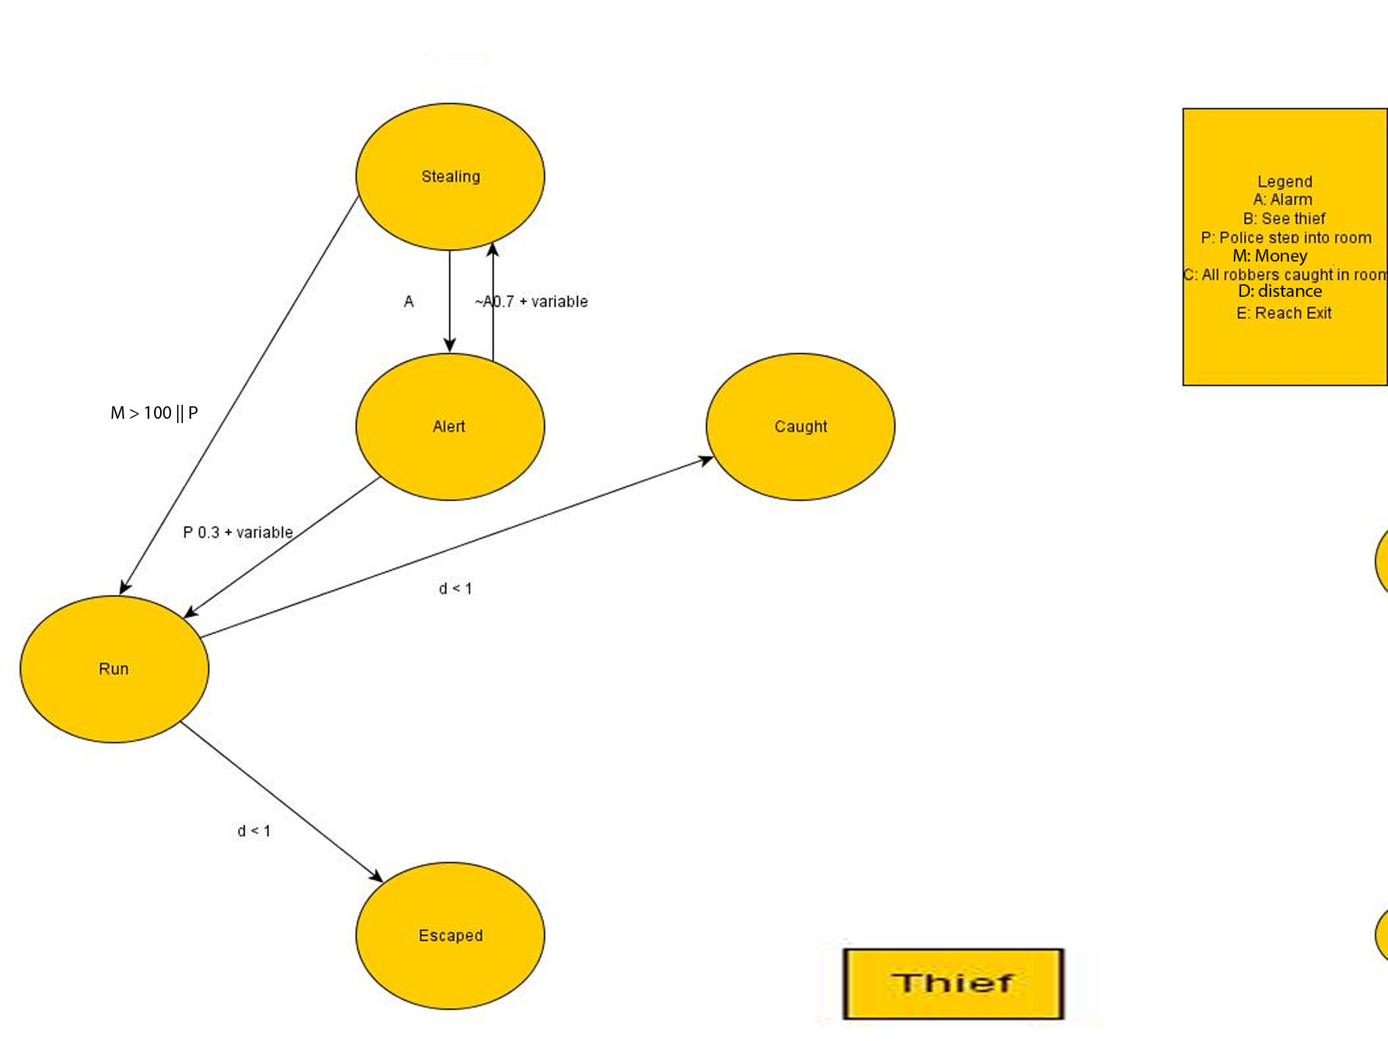
FSM # 2 States
Robber steals if alarm is not triggered
If robber has stolen their quota they head towards exit
If the alarm is triggered, robber have a chance to continue stealing or head towards exit
If robber is being chased by police, they will run towards the exit
If robber makes contact with the police, they are caught
If robber makes it to exit, he has escaped
Conditions

Robber steals if alarm is not triggered
If robber has stolen their quota they head towards exit
If the alarm is triggered, robber have a chance to continue stealing or head towards exit
If robber is being chased by police, they will run towards the exit
If robber makes contact with the police, they are caught
If robber makes it to exit, he has escaped
State Transition Diagram

